INTRODUCTION

We are so excited that you have chosen to take apply for a gap year with Elim Missions. We believe that this gap year is a great way to encounter God’s heart for the world and to be a part of the Biblical mandate to all believers in being His witnesses, to the ends of the earth (Acts 1:8).

GOALS

We understand that every placement we offer is unique, however, every placement will be underpinned by these 4 goals to a greater or lesser degree:

PROCLAMATION: To serve the purposes of sharing the good news of salvation

DISCIPLESHIP: To serve the purposes of discipling local believers and to encourage participants to become Christ-like and missional in their lives.

SOCIAL ACTION: To acknowledge missional access points and respond to human need through loving service.

SOCIAL JUSTICE: To serve and love all humanity as made in the image of God pursuing peace and reconciliation.

CORE VALUES

We understand that every placement will be unique but by being part of an Elim Missions gap year, we ask all individuals and teams to remember our core values regarding overseas placements:

BIBLICAL MANDATE: A distinctive element of short-term placements is an emphasis on Biblical principles and the mandate to be involved in mission.

BIBLICAL ATTITUDES: The attitudes of all involved are important and they need to be grounded in Biblical truth and spiritual integrity

PARTNERSHIP: Senders, goers and receivers are all participants in the mission and each has an important role.

LONG-TERM VISION: Short-term mission is a process and not an event and will facilitate the on going discipleship of the participant and the long-term objectives and activities of the hosts.

WHAT NOW?

To be considered for the gap year with Elim Missions we ask that you complete the following application form that will request your details, emergency contact info and also individuals we can obtain references from – we ask that you complete the application completely and honestly.

Once we receive your application we will seek references from those names submitted. You will then hear from us as the whether your application has been successful. We will invite you to an interview at Life Central Church in Halesowen, with the representatives from the Church and from Elim missions. This will be a chance for you to see the church and ask any questions about the course and also for us to get to know you. After the interview, we will write to you to confirm whether you will have a place on the Elim Missions Equip gap year.

Thank you for applying for the Elim Missions gap year – something that we know will be transformative for you and those you encounter.

Please be aware that all information pertaining to your application may be made available to the relevant Elim Missions Staff and missionary/Elim Global partner directly involved in your placement. No information provided on this application will be given to any persons or organisations beyond this. To see our Privacy Policy in full visit www.elim.org.uk/privacypolicy or ask for a copy from our Data Protection Officer; email dpo@elimhq.net or write to The Data Protection Officer, Elim International Centre, De Walden Road, Malvern WR14 4DF.
Data Protection Act 1988: The applicant should be aware the ELIM FOURSQUARE GOSPEL ALLIANCE will retain on record what is classified by the Data Protection Act 1998 as sensitive personal data as well as personal data. This requires the express consent of the Applicant and completing and submitting this Application you will be deemed to be giving consent to the retaining of such data and acknowledging that the process is necessary in performing or exercising a right or obligation in connection with the Applicant's appointment.

GAP YEAR APPLICATION

Married couples please complete separate forms

APPLICANT’S DETAILS

FULL NAME
(AS IT APPEARS ON PASSPORT):
ADDRESS:
MOBILE TEL: |  |  |  |  | HOME TEL:
EMAIL:
AGE: |  |  |  |  | DATE OF BIRTH:
NATIONALITY (AS IT APPEARS ON PASSPORT):
PASSPORT NUMBER (A VALID DATE MUST BE MINIMUM OF 6 MONTHS FROM RETURN DATE):
TICK AS APPROPRIATE: |  |  | MARRIED  SINGLE   WIDOWED  DIVORCED   SEPERATED  OTHER 
IF YOU HAVE CHILDREN PLEASE GIVE DETAILS BELOW:
FULL NAME: |  |  |  | DATE OF BIRTH:
FULL NAME: |  |  |  | DATE OF BIRTH:
FULL NAME: |  |  |  | DATE OF BIRTH:

REFERENCE DETAILS

WE REQUIRE TWO REFERENCES ONE OF WHICH MUST BE COMPLETED BY YOUR PASTOR. (REFERENCES MUST BE SENT TO US IN ENGLISH)

CHURCH NAME:
CHURCH ADDRESS:

REFERENCE 1:

PASTOR’S NAME:
E-MAIL ADDRESS (IF NOT KNOWN PLEASE SUPPLY HOME ADDRESS)

REFERENCE 2:

FULL NAME:
E-MAIL ADDRESS (IF NOT KNOWN PLEASE SUPPLY HOME ADDRESS)
IN WHAT CAPACITY DO YOU KNOW THIS PERSON? (EMPLOYMENT/CHURCH)

GENERAL QUESTIONS

HOW DID YOU BECOME A CHRISTIAN AND HOW DOES THIS IMPACT YOUR LIFE TODAY?

PLEASE GIVE FULL DETAILS (INC. OVERSEAS) OF YOUR EXPERIENCE IN CHRISTIAN WORK, WITH PARTICULAR REFERENCE TO YOUR CHURCH LIFE:
HAVE YOU DONE ANY PERSONAL WITNESSING FOR CHRIST? GIVE DETAILS.

WHY DO YOU WANT TO DO A GAP YEAR/INTERNSHIP?

WHAT DO YOU HOPE TO GAIN BY DOING A GAP YEAR/INTERNSHIP?

WHAT IS YOUR EVERYDAY LANGUAGE:

PLEASE INDICATE ANY OTHER LANGUAGES YOU SPEAK:

SKILLS & HOBBIES

HAVE YOU ANY EXPERIENCE OR QUALIFICATIONS IN ANY OF THE FOLLOWING:

FIRST AID  NURSING  MIDWIFERY  MEDICINE  MUSIC  COOKERY  BOOK-KEEPING  COMPUTERS AND IT |                | CARPENTRY  BUILDING  MOTOR MECHANICS  PLUMBING  ELECTRICAL INSTALLATION  DRIVING  TEACHING  ADMINISTRATION |               
WHAT ARE YOUR AREAS OF INTEREST? (PLEASE TICK ALL THAT APPLY)
-YOUTH WORK
- CHILDREN’S WORK
- WORSHIP
- MEDIA & DESIGN
- PERFORMING ARTS
- COMMUNITY WORK
- EVANGELISM
- OVERSEAS DEVELOPMENT
- LEADERSHIP
- OTHER (PLEASE GIVE DETAILS)

WHAT EXPERIENCE DO YOU HAVE WORKING IN THE ABOVE AREAS (INC WITHIN YOUR LOCAL CHURCH)?

HOW DO YOUR FRIENDS AND FAMILY FEEL ABOUT YOU DOING THIS PLACEMENT?

WHAT WOULD YOU LIKE TO BE DOING IN 5 YEARS TIME?

EDUCATION AND EMPLOYMENT QUESTIONS

PLEASE GIVE DETAILS OF HIGHEST LEVEL OF EDUCATIONAL QUALIFICATIONS AND DATES:

EMPLOYER/EDUCATION ESTABLISHMENT | JOB TITLE/QUALIFICATIONS | DATES

EMERGENCY CONTACT INFORMATION

FULL NAME

ADDRESS:
POSTCODE: |  |  | COUNTRY:

TEL (DAYTIME): |  |  | Tel (EVENING):

TEL (MOBILE): |  |  | EMAIL:

RELATIONSHIP (PARENT / PASTOR / SIBLING ETC):

YOUR DOCTOR:

FULL NAME

SURGERY ADDRESS:
POSTCODE: |  |  | TEL::

MEDICAL INFORMATION:
DO YOU HAVE ANY MEDICAL CONDITIONS / DISABILITIES / ALLERGIES (FOOD/MEDICATION ETC)?
YES  NO 
IF YES PLEASE GIVE DETAILS:

ARE YOU TAKING ANY MEDICATION? YES  NO 
IF YES PLEASE GIVE DETAILS:

DATE OF LAST TETANUS: |  |  | BLOOD GROUP (IF KNOWN)

INSURANCE:
COMPANY AND POLICY NUMBER:

HAVE YOU HAD A CRIMINAL RECORDS CHECK WITHIN THE LAST 3 YEARS THROUGH THE ELIM PENTECOSTAL CHURCH (WE ARE UNABLE TO ACCEPT CHECKS THROUGH OTHER ORGANISATIONS) | YES  NO 

IF ‘YES’ PLEASE COULD YOU ATTACH A COPY OF YOUR DBS (FORMERLY CRB) CERTIFICATE TO YOUR COMPLETED APPLICATION FORM.

IF ‘NO’ WE WILL NEED TO DO OUR OWN CRIMINAL RECORDS CHECK AND WILL SEND YOU DETAILS OF HOW TO DO THIS ONLINE THROUGH THE DISCLOSURE & BARRING SERVICES E-BULK SYSTEM.

As an organisation we undertake to meet the requirements of the Data Protection Act 1998, and all appropriate Acts in relation to Criminal Record Disclosures (see Self Declaration Form).

Self-Declaration Form (Enhanced Disclosure)

Self-declaration Form for a Position Requiring an Enhanced Level Check/Enhanced Level Check with Barring Disclosure

STRICTLY CONFIDENTIAL
As a place of worship/organisation we undertake to meet the requirements of the Data Protection Act 1998 and all amendments made on or before May 25th, 2018 and all other relevant legislation, and the expectations of the Information Commissioners Office relating to the data privacy of individuals.
All applicants that require an Enhanced Disclosure are asked to complete this form, detach it from the Application Form and return it, to the Recruiter detailed below, in a separate sealed envelope

To: AMANDA CAMPBELL
(Name of Recruiter/responsible person in place of worship/organisation processing Criminal Records Disclosure checks)

Address: ELIM INTERNATIONAL MISSIONS, DE WALDEN ROAD, WEST MALVERN, WR14 4DF

Appointment applied for: OVERSEAS WORKER WITH CHILDREN & VULNERABLE ADULTS

CONVICTION HISTORY

If you have never been convicted of a criminal offence or never received a caution, reprimand or warning then please select ‘No’ below. If you have been convicted of a criminal offence, or received a caution, reprimand or warning that is now spent according to DBS filtering rules*, then please select ‘No’ below.

If you have an unspent criminal offence, caution, reprimand or warning (according to DBS filtering rules*), please select ‘Yes’ below.

For exceptions to this legislation or for more information please refer to the Rehabilitation of Offenders Act 1974** and the DBS filtering guidance*.

Having read the above, do you have any unspent convictions; or are you at present the subject of a criminal investigation/pending prosecution?
Yes No (please tick)

If yes, please give details including the nature of the offences and the dates. Please give details of the court(s) where your conviction (s) were heard, the type of offence and sentence(s) received. Could you also give details of the reasons and circumstances that led to the offence(s)? Continue on a separate sheet if necessary.
___________________________________________________________________________________________________________________________________________________________________________________________________________________________________________________
For notes marked with an asterisk, please see links below

(Please amend the following questions as is applicable to the role being applied for)

- If the role is in relation to children and young people, has there ever been any cause for concern regarding your conduct with children, young people?
Yes No (please tick)
If yes, please give details.
____________________________________________________________________________________________________________________________________________________________________________________________

- If the role is with adults at risk/care and support needs has there ever been any cause for concern regarding your conduct with adults?
Please include any disciplinary action taken by an employer in relation to your behaviour with children, young people or adults at risk (as applicable). Yes No (please tick)

If yes, please give details.
____________________________________________________________________________________________________________________________________________________________________________________________

DECLARATION
To help us ensure that we are complying with all relevant safeguarding legislation, please read the accompanying notes and complete the following declaration.
I (full name) ________________________________ of (address) __________________________
consent to a criminal record check if appointed to the position for which I have applied. I am aware that details of pending prosecutions, previous convictions, cautions, or bind-overs against me may be disclosed along with any other relevant information which may be known to the police.

I agree to inform the person within the place of worship/organisation responsible for processing disclosure applications if I am convicted of an offence after I take up any post within the place of worship/organisation. I understand that failure to do so may lead to the immediate suspension of my work with children or vulnerable adults and/or the termination of my employment.

I agree to inform the person within the place of worship/organisation responsible for processing disclosure applications if I become the subject of a police and/or a social services/(Children’s Social Care or Adult Social Services)/Social Work Department investigation. I understand that failure to do so may lead to the immediate suspension of my work with children or vulnerable adults and/or the termination of my employment.

Signed: ______________________________ Date: ______________________
For notes marked with an asterisk, please see links below.

Those applying for work with children and/or adults at risk in positions which fall within the scope of regulated activity please confirm that you are not barred from working with children/vulnerable adults.

I confirm that I am not barred from working with children /adults at risk.

Signed: ______________________________ Date: _____________________

NB: Those applying for work with children and/or vulnerable adults in positions which fall outside the scope of regulated activity should not complete the declaration above.

*https://www.gov.uk/government/publications/filtering-rules-for-criminal-record-check-certificates

http://www.ccpas.co.uk/Documents/QRGDBSFiltering.pdf

**https://www.gov.uk/government/uploads/system/uploads/attachment_data/file/216089/rehabilitation-offenders.pdf

LEGALESE – ATTACHED NOTES

The Disclosure of any offence may not prohibit employment. Please refer to our Rehabilitation of Offenders Policy.
As this post involves working contact with children, young people and/or vulnerable adults all applicants who are offered an appointment will be asked to submit to a criminal record check before the position can be confirmed. You will be asked to apply for an Enhanced Disclosure through the Disclosure and Barring Service (DBS) (England & Wales).
As the position is exempted under the Rehabilitation of Offenders Act this check will reveal details of cautions, reprimands or final warnings, as well as formal convictions not subject to DBS filtering rules. Because of the nature of the work for which you are applying, this position is exempt from the provision of section 4(ii) of the Rehabilitation of Offenders Act 1974 (Exemptions Orders as applicable within the UK), and you are not entitled to withhold information about convictions which for other purposes are ‘spent’ under the provisions of the Act with the exception of those that are subject to the DBS filtering rules. In the event of appointment, any failure to disclose such convictions could result in the withdrawal of approval to work with children or vulnerable adults within the church/organisation.
This process is subject to a strict code to ensure confidentiality, fair practice and security of any information disclosed. The DBS Service Code of Practice and our own procedures are available on request for you to read. It is stressed that a criminal record will not necessarily be a bar to appointment, only if the nature of any matters revealed could be considered to place children or vulnerable adults at risk. As a place of worship/organisation we agree to abide by the Code of Practice on the use of personal data in employee/employer relationships under the Data Protection Act 1998 and all amendments made on or before May 25th 2018 ( the date of GDPR coming into effect), as well as the expectations of the DBS.

Notes for England and Wales - Children and Young People
Under the Protection of Freedoms Act 2012 it is an offence for any organisation to offer employment to anyone who has been convicted of certain specific offences, or included on either of the two barred lists held by the Disclosure and Barring Service where the post falls within the scope of regulated activity (as defined by the DBS, under the Safeguarding Vulnerable Groups Act 2006 and the Protection of Freedoms Act 2012). An enhanced with barred list check must be completed. Those working with children and / or vulnerable adults in posts which fall outside the scope of regulated activity may still be eligible for an enhanced disclosure WITHOUT a barred list check.
The Disclosure and Barring Service (DBS) was established under the Protection of Freedoms Act 2012 and merges the functions previously carried out by the Criminal Records Bureau (CRB) and Independent Safeguarding Authority (ISA). The DBS came into existence on 1st December 2012. The DBS offers both an enhanced check and for those engaged in regulated activity an enhanced with a barred list check.

DBS Eligibility from: https://www.gov.uk/government/publications/dbs-check-eligible-positions-guidance
Page 12

FUNDING SHORT-TERM PLACEMENTS
Although we do not charge anything by way of an administration fee for applications there are costs incurred to Elim Missions for every application we process. We would therefore ask that you consider supporting the work of Elim Missions so we can continue to offer amazing short-term teams at such a low cost by becoming part of POUND BY POUND.

POUND BY POUND simply means giving Elim Missions £1 per week - 100% of this donation goes to Elim Missions and helps us keep sending teams overseas and also facilitates the work we do with our missionaries and partners around the world - seeing many come to Christ.

£1 a week might not seem much, and it isn't really but a little from a large number of people really does have a huge impact. Please consider supporting Elim Missions so others just like you can experience mission and we can see Jesus taken into every nation on earth.

START POUND BY POUND TODAY: https://www.elimmissions.co.uk/poundbypound
OR SIMPLY COMPLETE THE ENCLOSED FLYER AND SEND BACK TO US ALONG WITH YOUR APPLICATION FORM. THANK YOU.

APPLICANTS SHOULD ENCLOSE:

- COMPLETED APPLICATION FORM AND POUND BY POUND FORM
- COMPLETED CCPAS SELF DECLARATION FORM
- A RECENT PHOTOGRAPH
- COPY OF PASSPORT PAGE SHOWING NAME AND PHOTOGRAPH

PLEASE RETURN COMPLETED APPLICATION AND POUND BY POUND FORM TO:

Elim International Missions, Elim International Centre, De Walden Road, West Malvern WR14 4DF

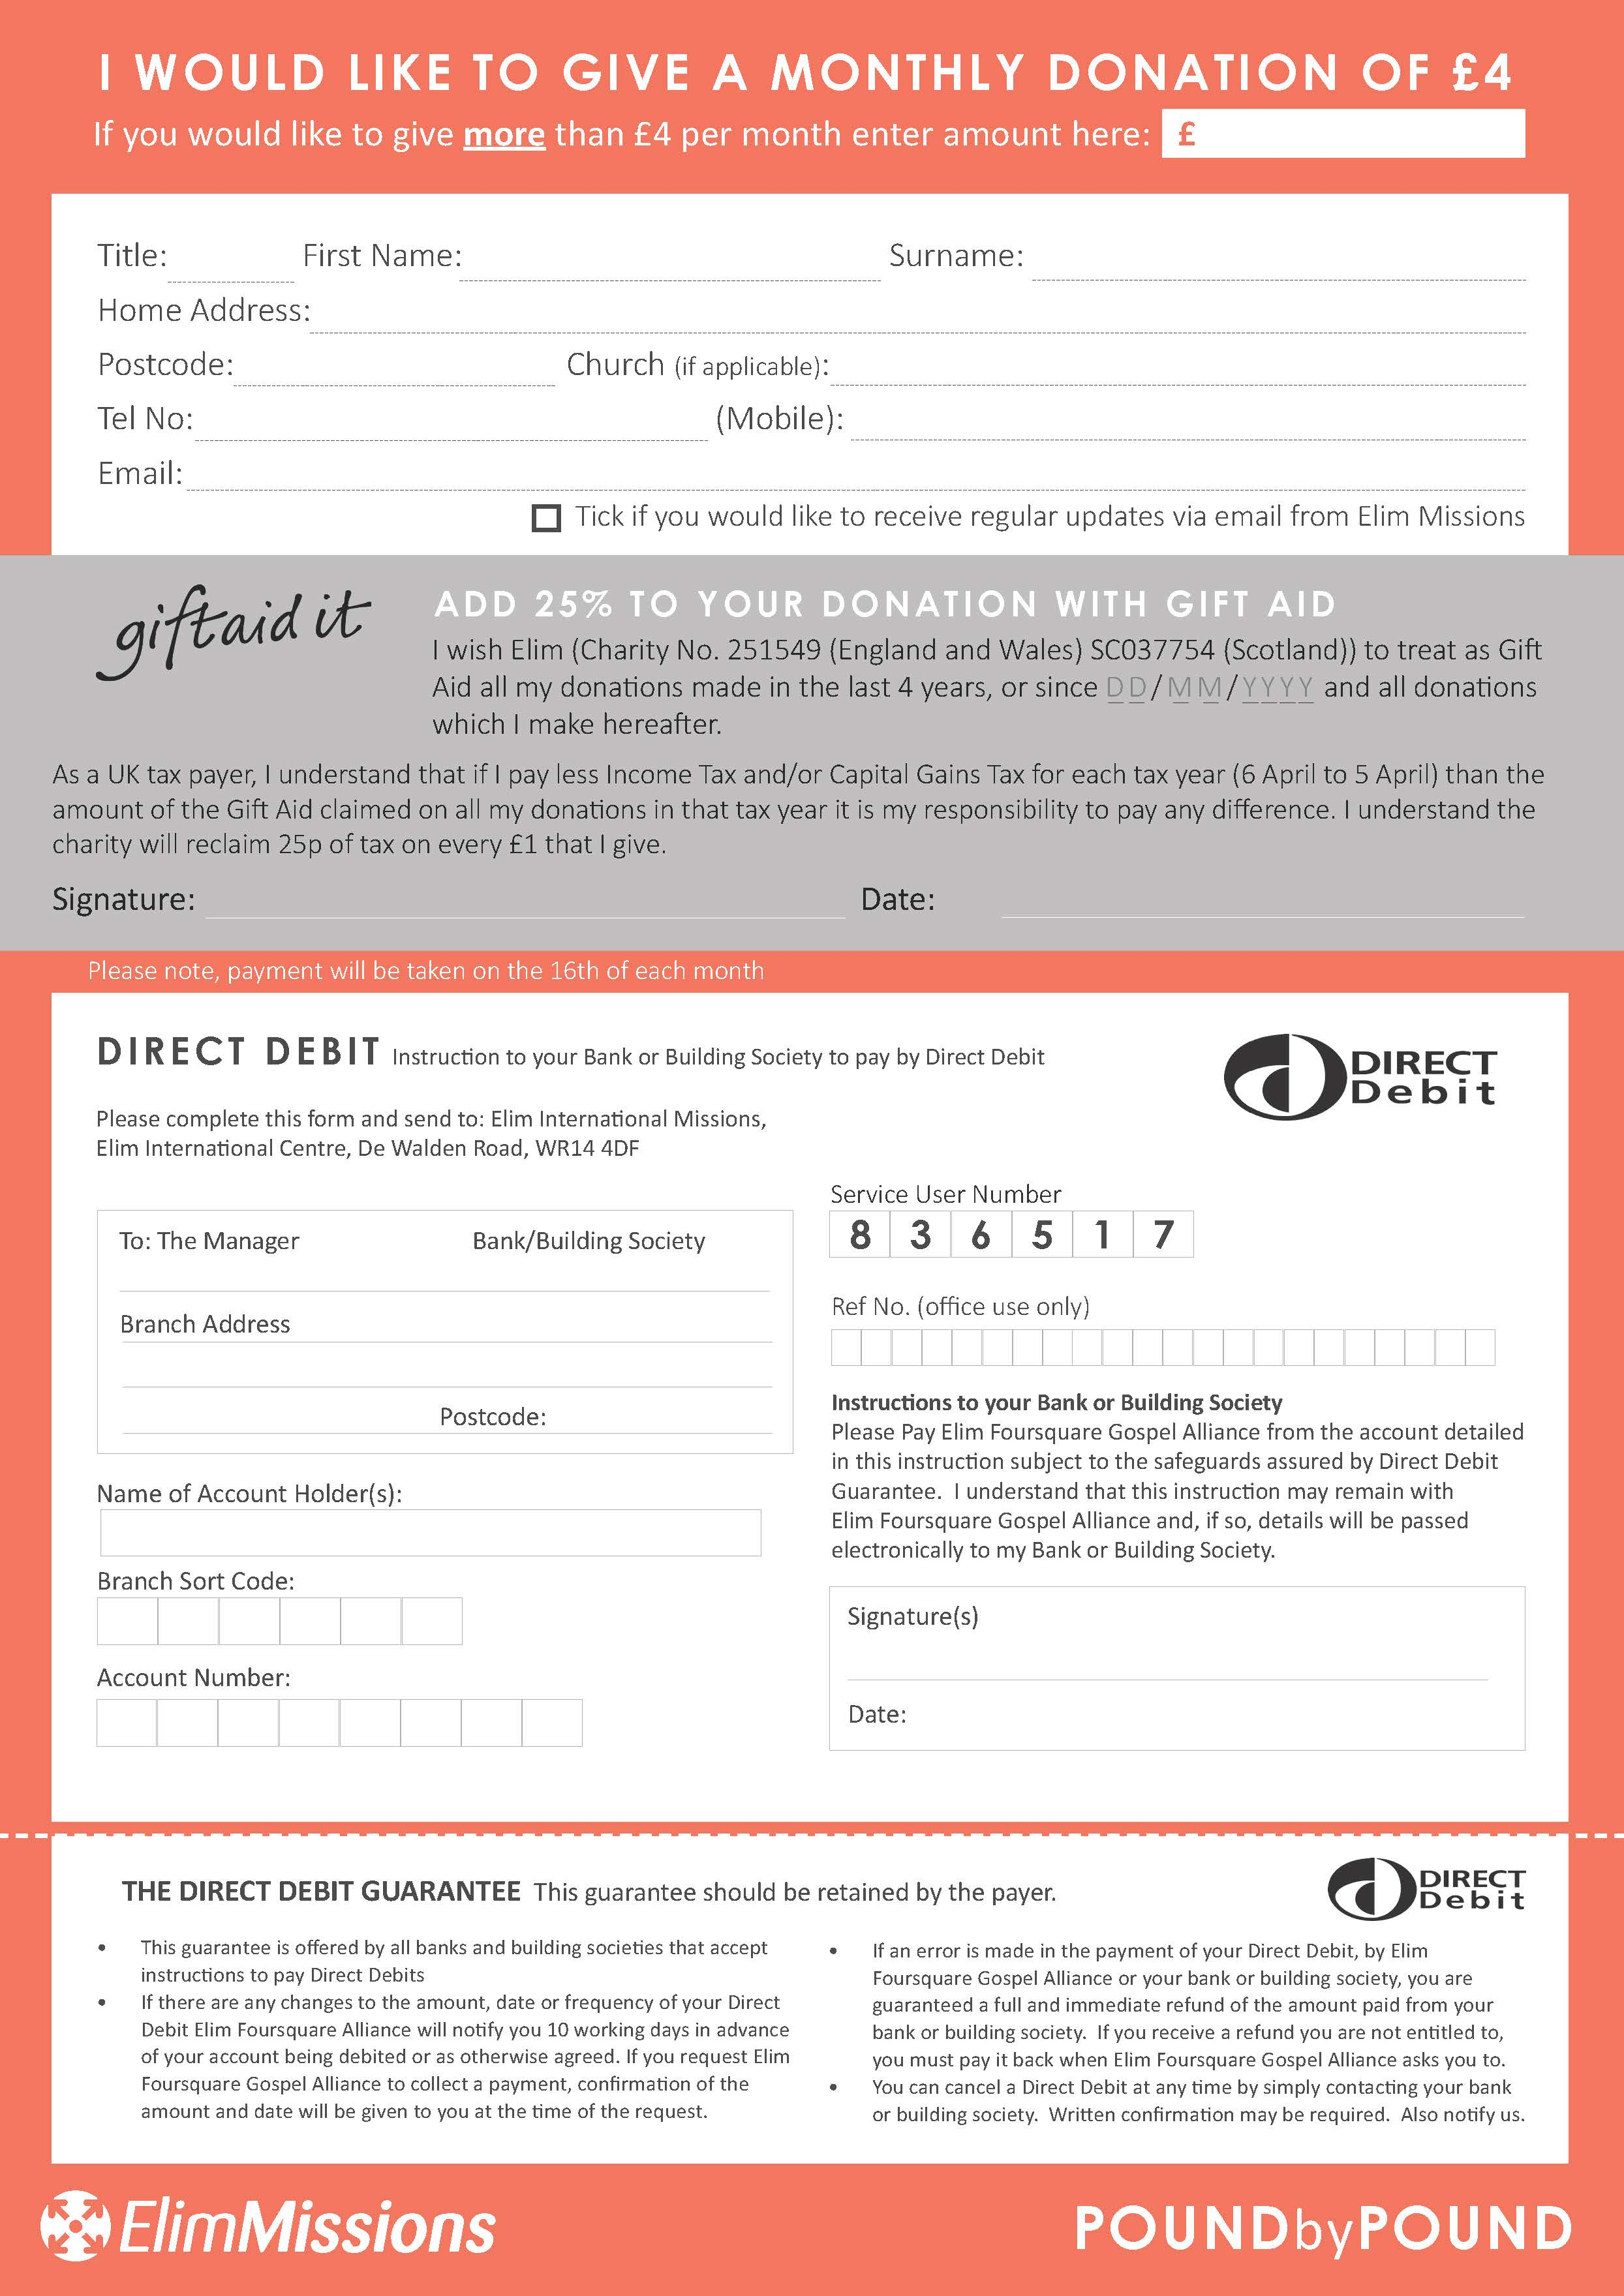
Data Protection Act 1988: The applicant should be aware the ELIM FOURSQUARE GOSPEL ALLIANCE will retain on record what is classified by the Data Protection Act 1998 as sensitive personal data as well as personal data. This requires the express consent of the Applicant and by signing this Application you will be deemed to be giving consent to the retaining of such data and acknowledging that the process is necessary in performing or exercising a right or obligation in connection with the Applicant's appointment.

